IP24: Text for social media posts
Card 1:
Recently had an overnight stay in an NHS hospital?
Lookout for the #AdultInpatientSurvey arriving in the post soon. Your valuable feedback will help us improve the quality of our care and people’s experience.
Social media card: Take action
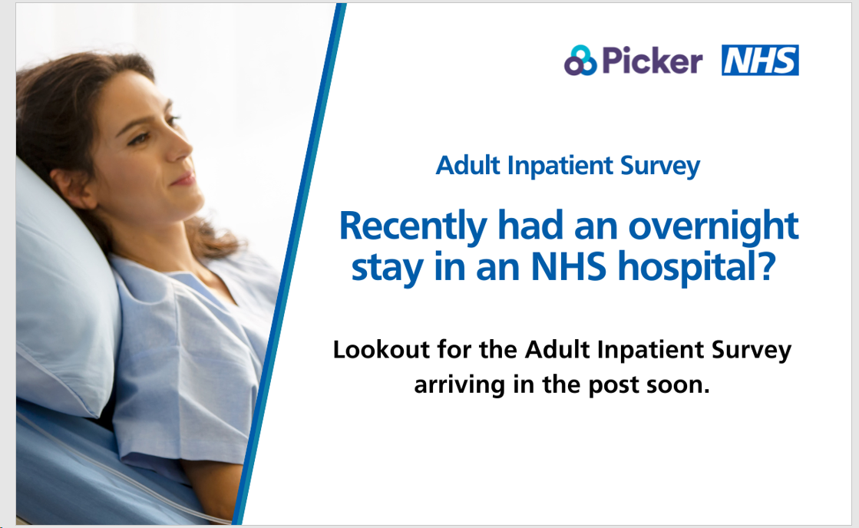
Card 2:
Take the opportunity to make a difference to NHS Adult Inpatient services.
We’d love to hear about your experience of your overnight stay in hospital. The best way for us to improve your care is by hearing from people who have recently used our services.
#AdultInpatientSurvey
Social media card: Reminder One
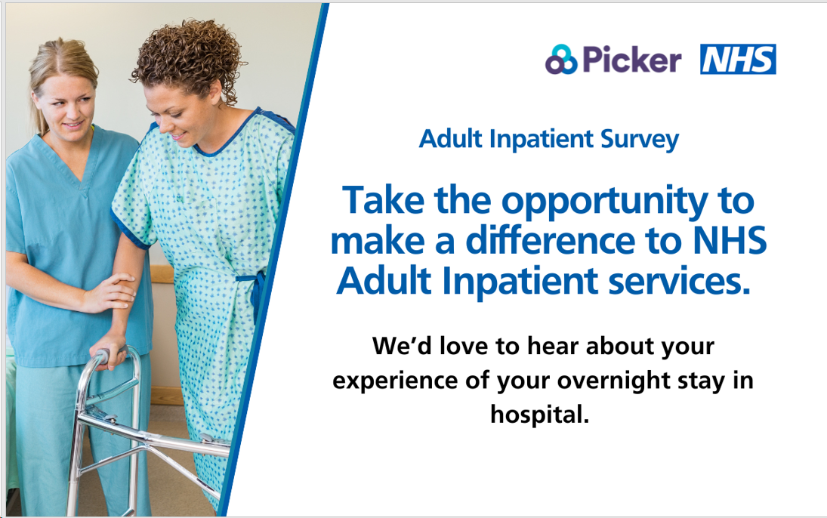

Card 3:
Will you take a moment to share your experience of your overnight stay in hospital? Lookout for your #AdultInpatientSurvey in the post.
Please complete the survey and help us make a positive difference to our care and services.
Social media card: Reminder Two
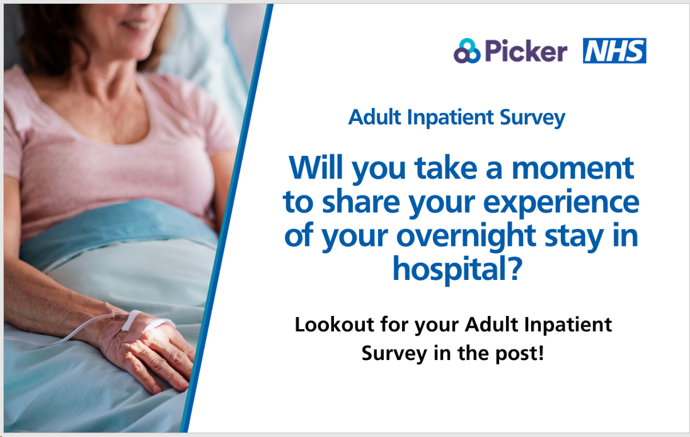
Card 4:
Recently used NHS Adult Inpatient services? This is your chance to give feedback on your overnight stay in hospital.
We are listening closely to what you have to say, your response will help us improve inpatient services for you and our community.
#AdultInpatientSurvey
Social media card: Reminder Three
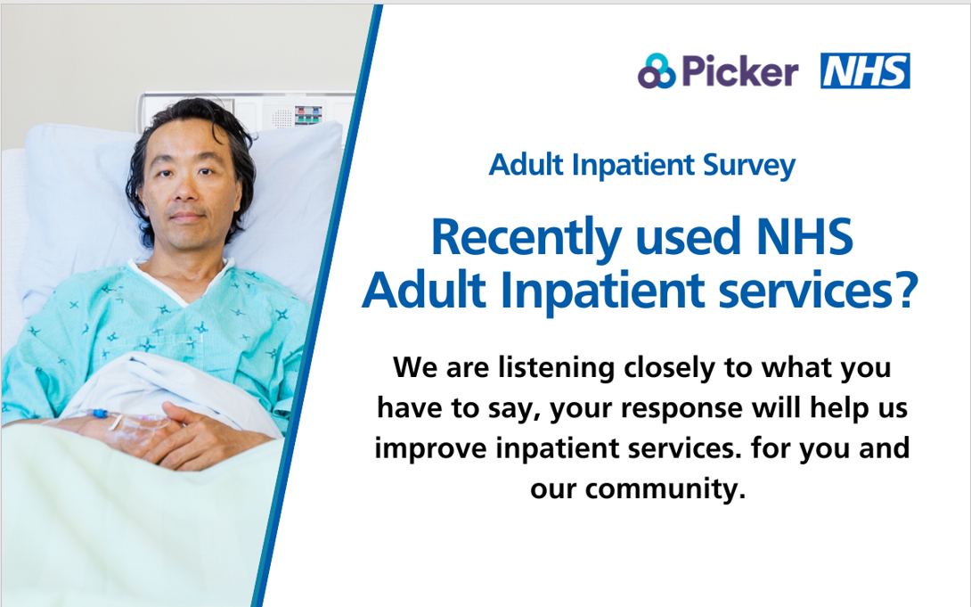

The NHS Adult Inpatient Survey has Section 251 (NHS Act 2006) approval to process contact details.

